|  |  |  |  |  |  |  |  |
| --- | --- | --- | --- | --- | --- | --- | --- |
|  | | | |  |  |  |  |
|  |  |  |  |  |  |  |  |
| **Student ID Number**  *(Do not include student name as anonymous marking is implemented)* | **Radu Garaz/GAR19472838** | | | | | | |
| **Programme Title** | **Computing Technologies Extended Degree (QA)** | | | | | | |
| **Module Title** | **Cyber Security** | | | | | | |
| **Module Code** *(listed on Moodle and in LTAFP)* | **QAC020X352S** | | | | | | |
| **Module Convenor** |  | | | | | | |
| **Coursework Title** | **Coursework 1** | | | | | | |
| **Academic Declaration:**  *Students are reminded that the electronic copy of their essay may be checked, at any point during their degree, with Turnitin or other plagiarism detection software for plagiarised material.* | | | | | | | |
| **Word Count** |  | | | **Date Submitted** | |  | |
|  |  | | |  | |  | |
|  | | | | | | | |

# CYBER SECURITY

Table of Contents

CYBER SECURITY 2

Introduction: 3

Task 1: 3

Creating Virtual Environment: 3

Now start the machine to use the environment. 13

Logging into the Kali Linux VM 13

Task 2: 15

(A). Demonstrate the steps a hacker can perform for network scanning using any appropriate tools and analyse their results 16

Installing NMAP 17

Network Scanning 17

Network Scanning using IP#. 18

Exploiting port using Metasploit “Metasploit-Framework” 19

Checking the information of Remote host and Remote Port 21

Exploit Successful. 22

(C) Man in Middle Attack 22

(D) Penetrating and Hacking the Data from HTTPS 23

(E) Network Access hacking using WIFI. 23

(F) Social Engineering Attack 30

Types of phishing attack: 30

Tools use for Social engineering Attack 30

Task 3 34

Protection from social engineering attack 34

Task 4 34

Conclusion 34

Reference(s): 35

# Introduction:

Network security is the process of protecting a network from unauthorized access and damage. Network security involves protecting both system components and applications.

Website penetration testing is a computer security assessment designed to find vulnerabilities in web applications, especially in order to determine how easy it is for an attacker to exploit those vulnerabilities and gain access to sensitive information or control of the system.

Network Security Testing (NST) provides a methodology that allows one to test a network's security with existing tools, without having to buy expensive equipment or hire IT staff. The NST team conducts tests using different methods, including using open source software and commercial tools.

# Task 1:

## Creating Virtual Environment:

System requirement to installing virtual environment.

8GB of RAM

Minimum 80GB of Hard Disk or SSD

Windows 8.1 or Higher

VirtualBox and Extension Pack

Kali Linux ISO

Installing Oracle VM VirtualBox 6.1.34 using Wizard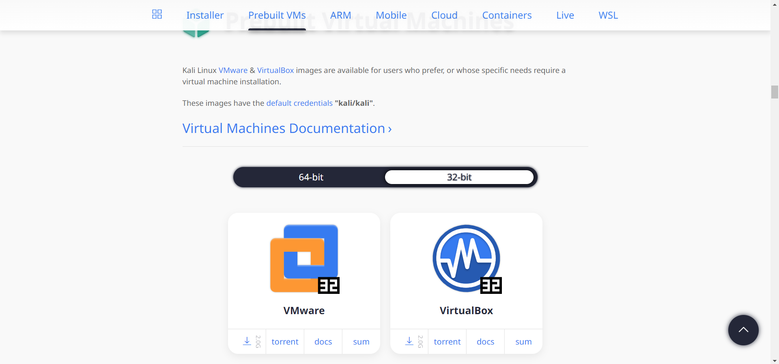

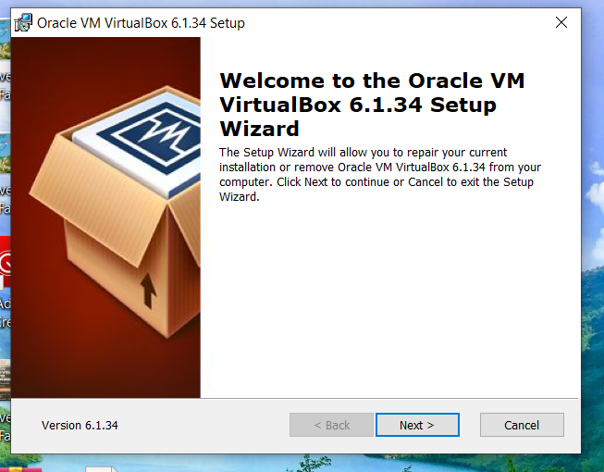

In this coursework we are going to use Kali Linux and its tools for network scanning and website testing.

Once the VirtualBox has been installed then move to install kali environment using wizard.

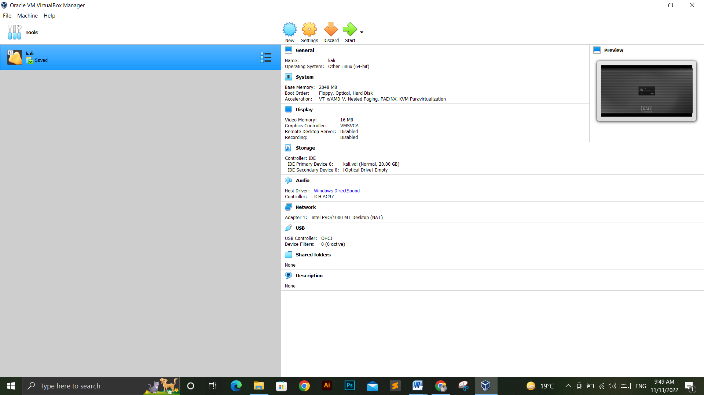

Enter the name of machine and select the machine with its version.

In this, we are going to use Kali Linux as Type and Oracle 64bit as version.

Click “Next” to go forward.

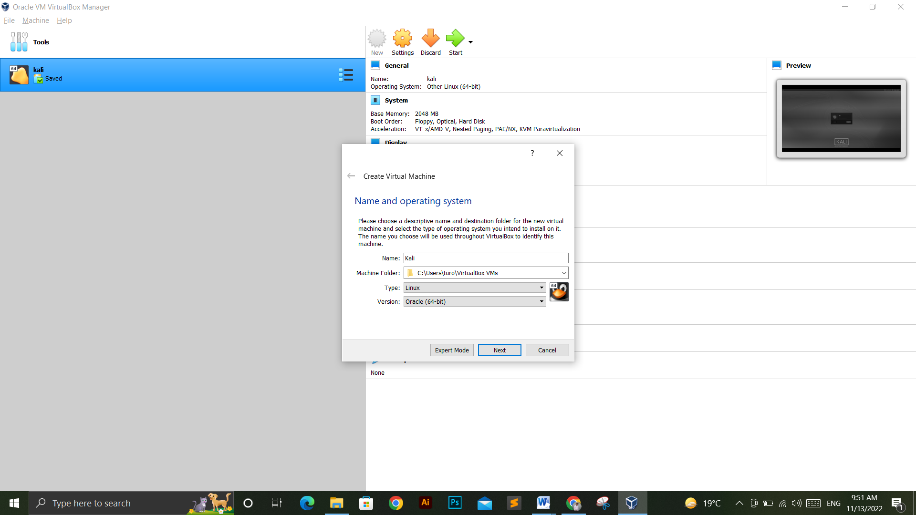

Selecting the memory size for virtual machine.

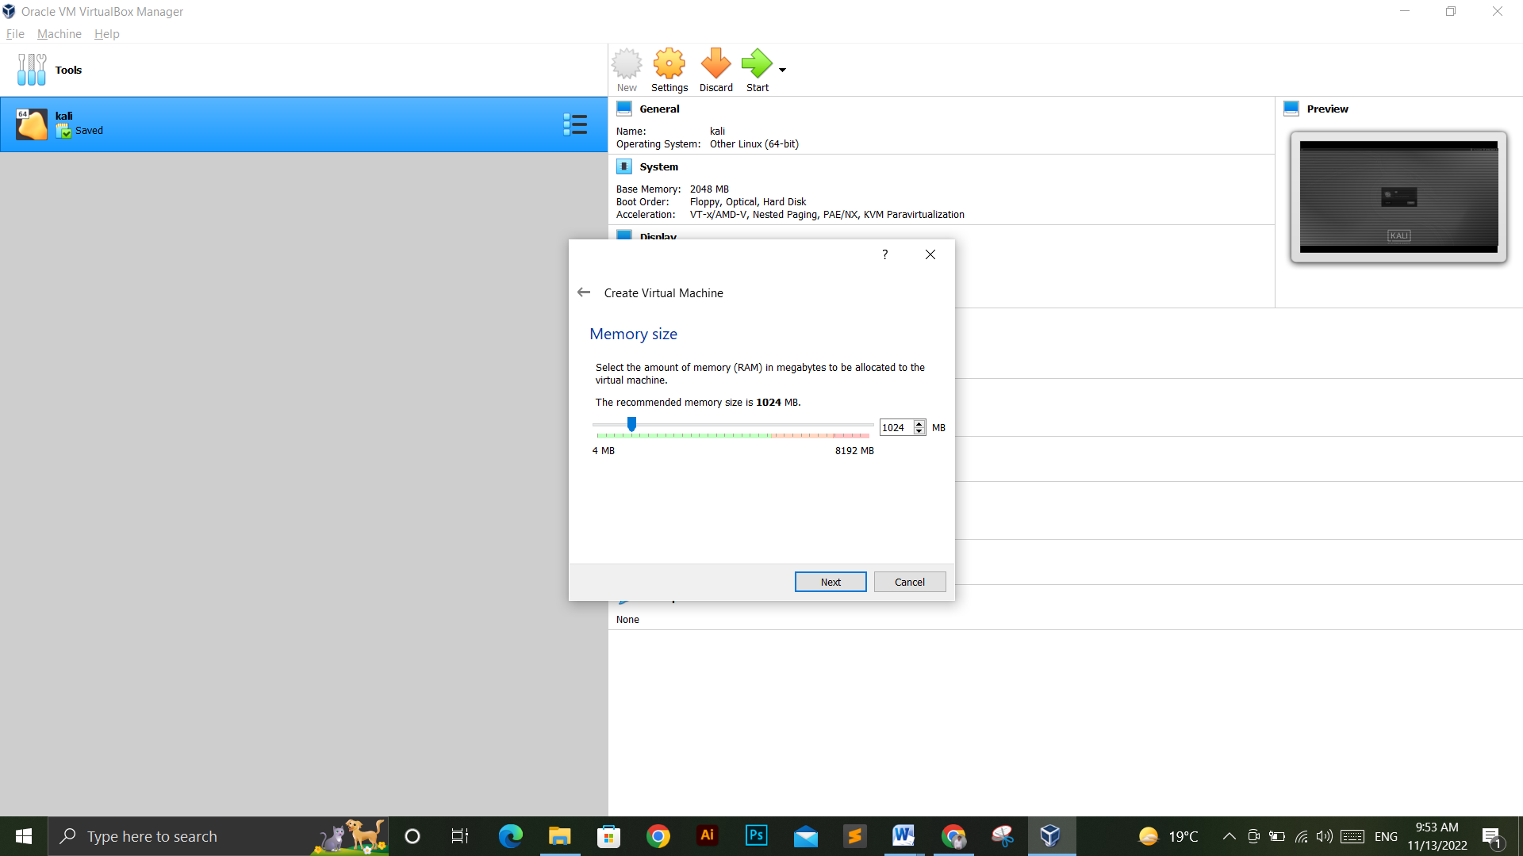

We are assigning 4096 Mega Bytes as RAM size for our virtual Machine.

Now, to add virtual hard disk in the system

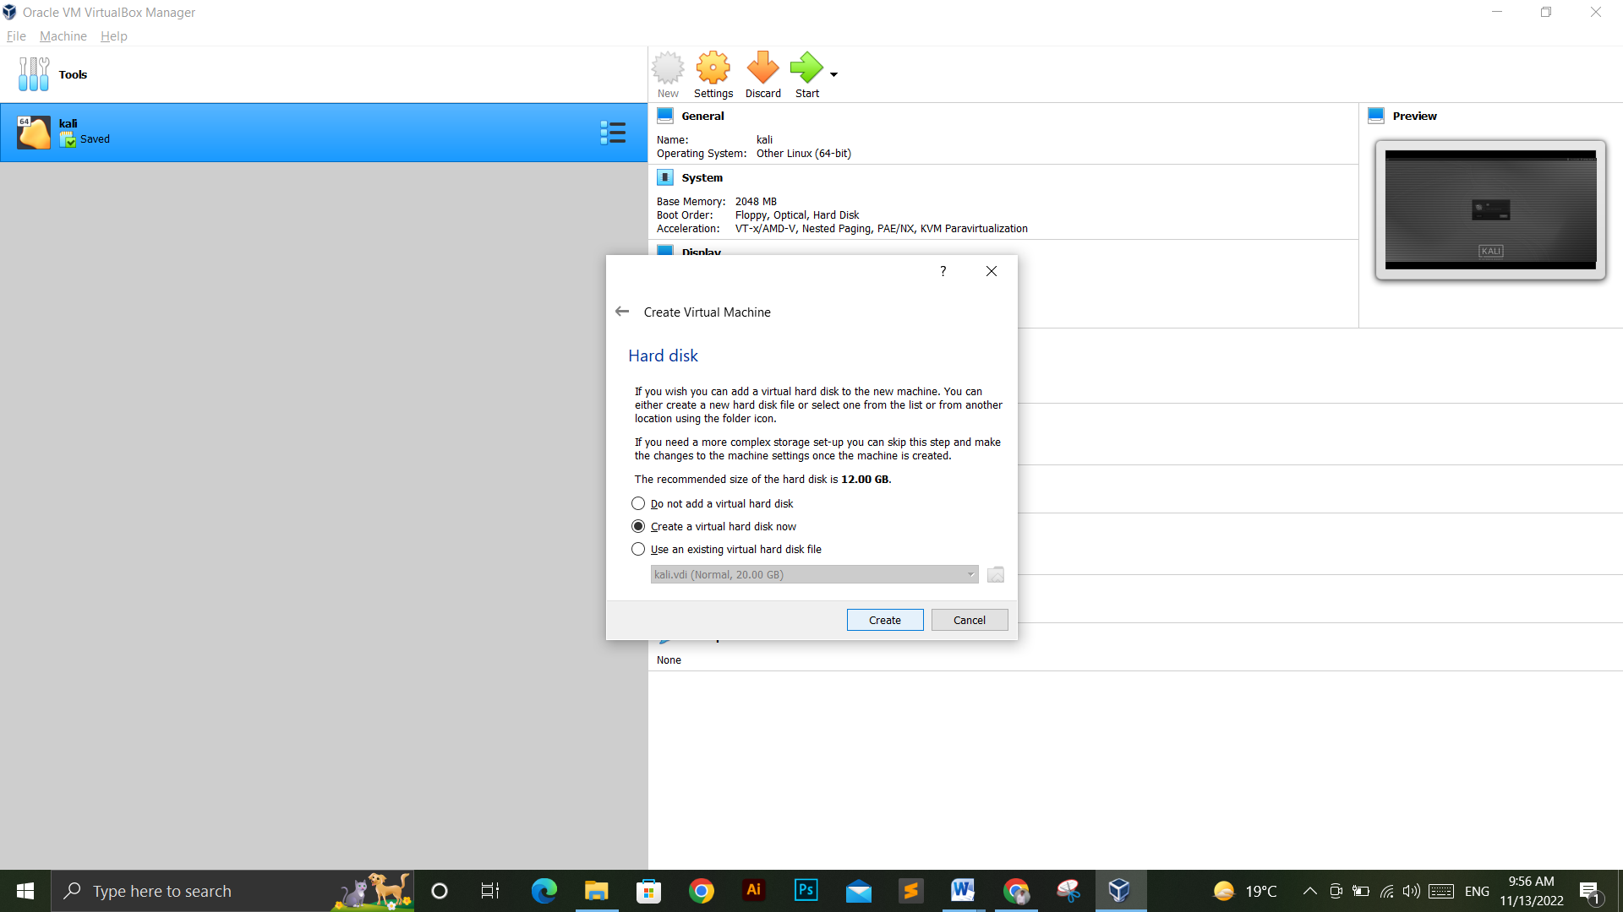

We have selected the “Create Virtual Hard Disk Now”

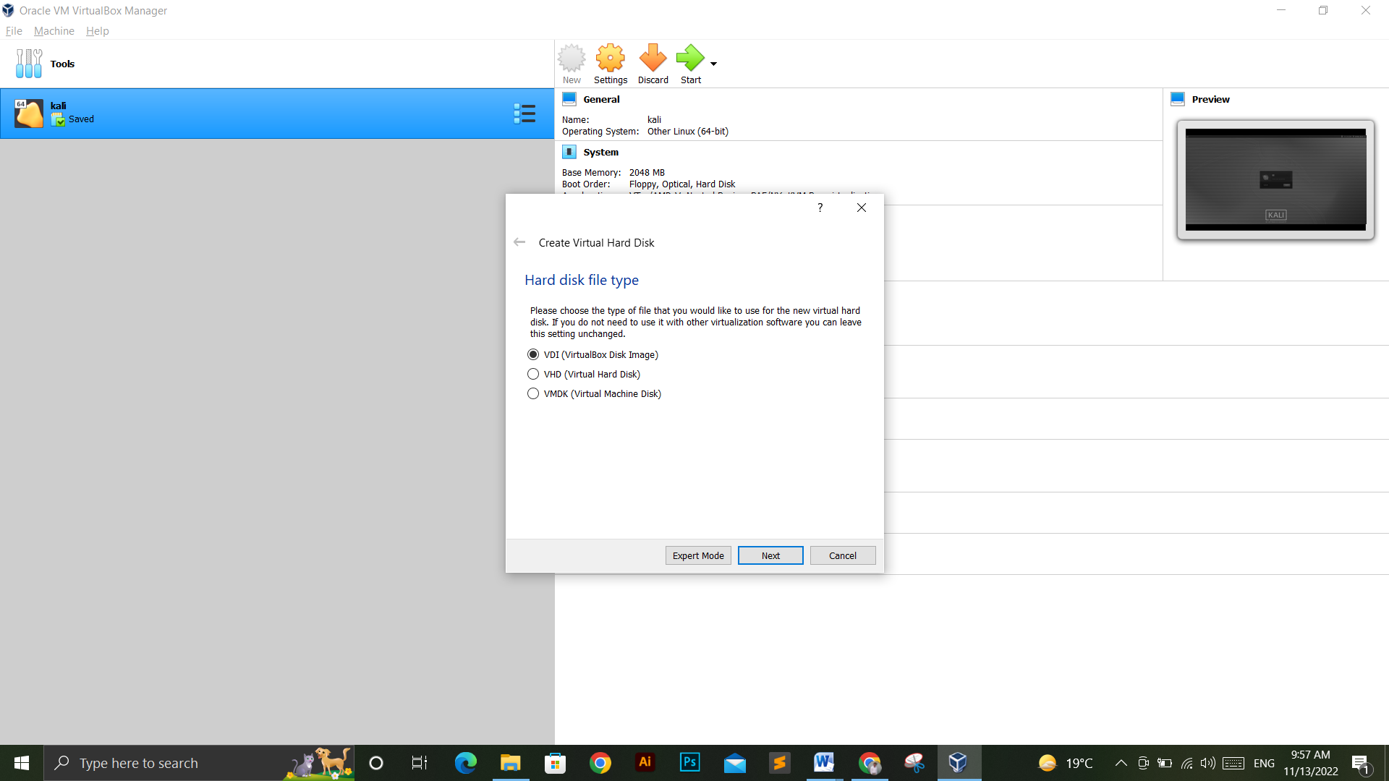

Select the storage type

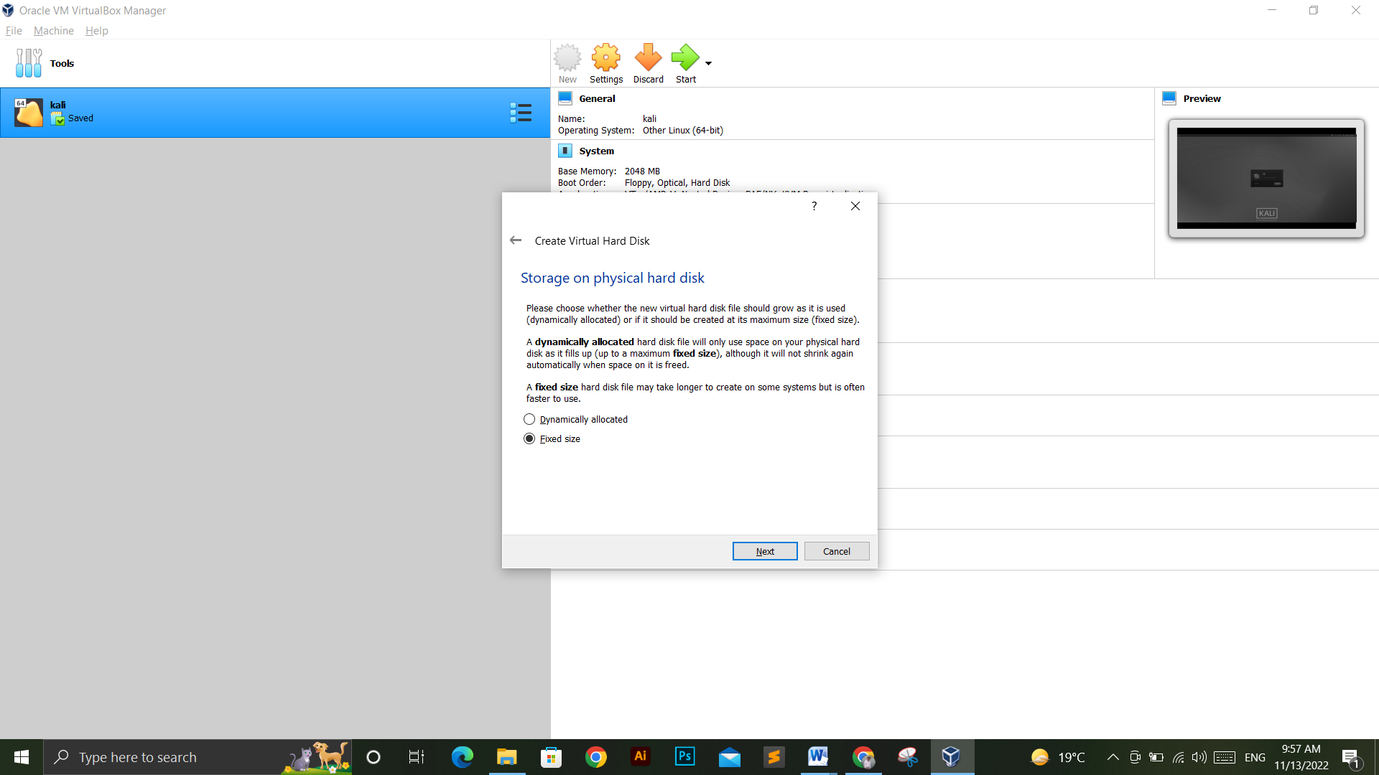

Assigning the disk size.

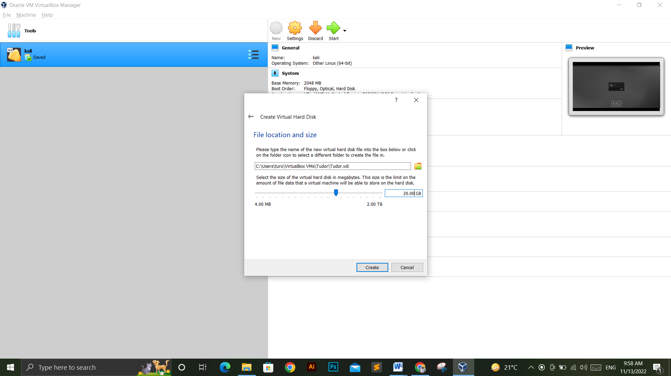

Now the installation wizard is about to complete.

Now we have to do setting before starting the syste.

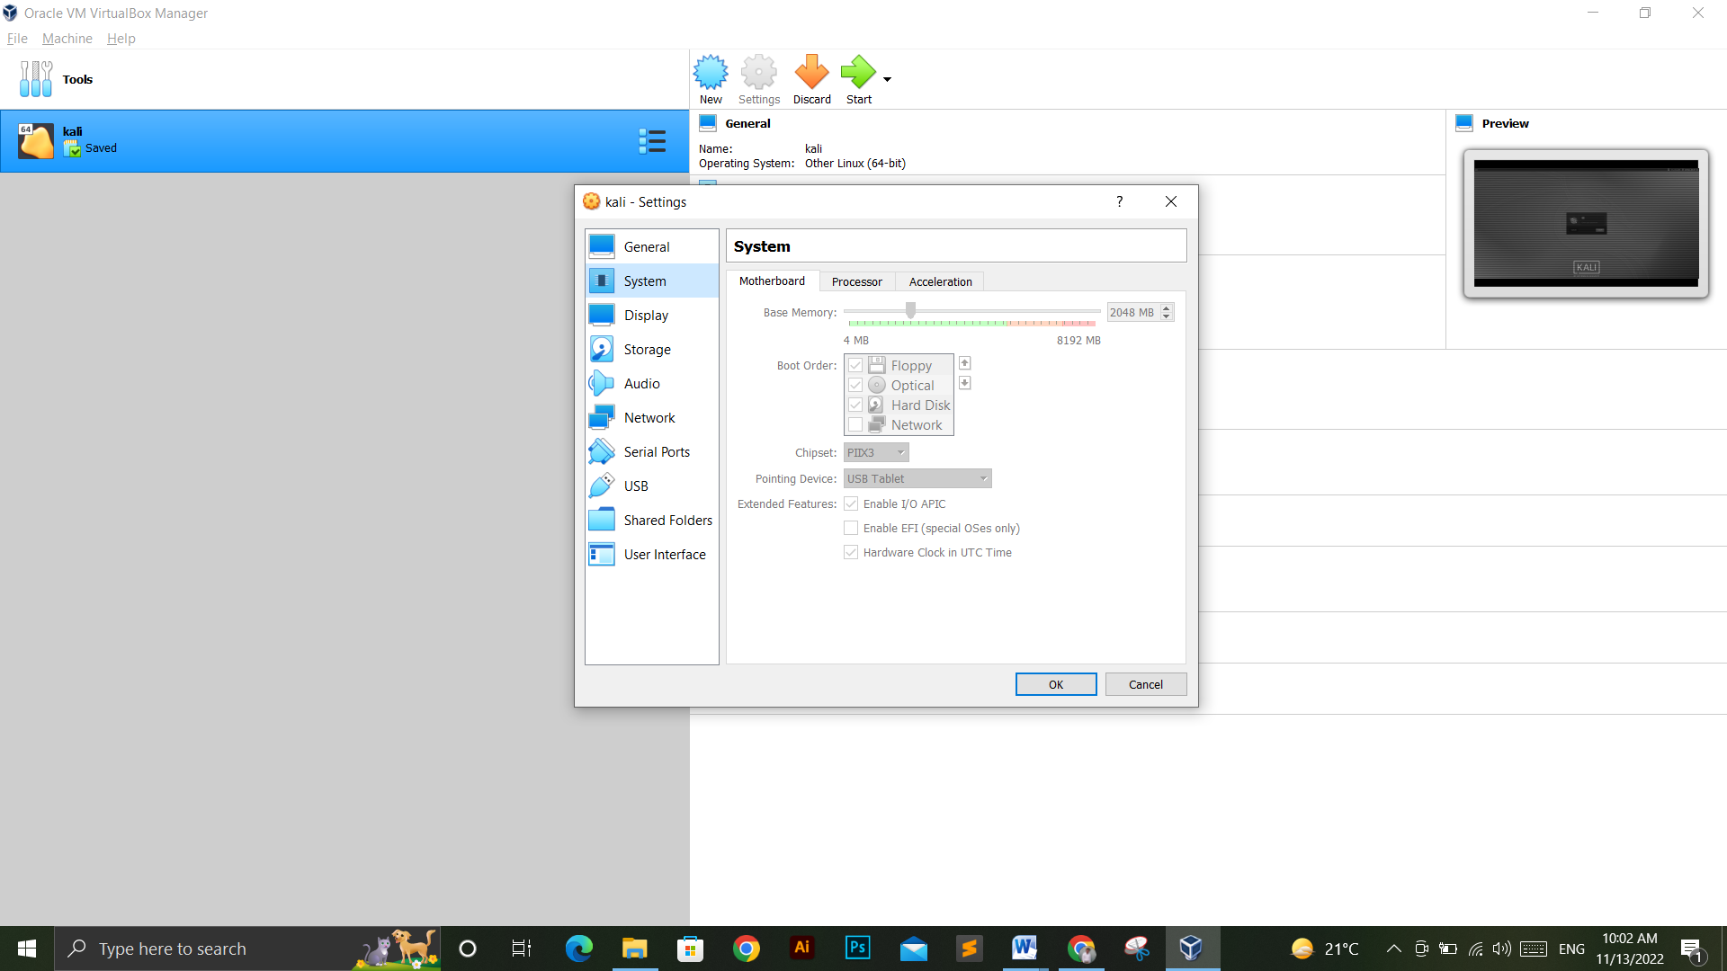

Setting up the MotheBoard and Processor Setting.

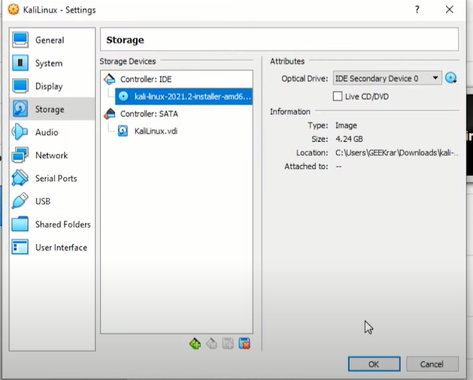

Selecting the kali Linux ISO file to install.

Now the Wizard is completed.

Now start the Machine and then the kali installations begins.

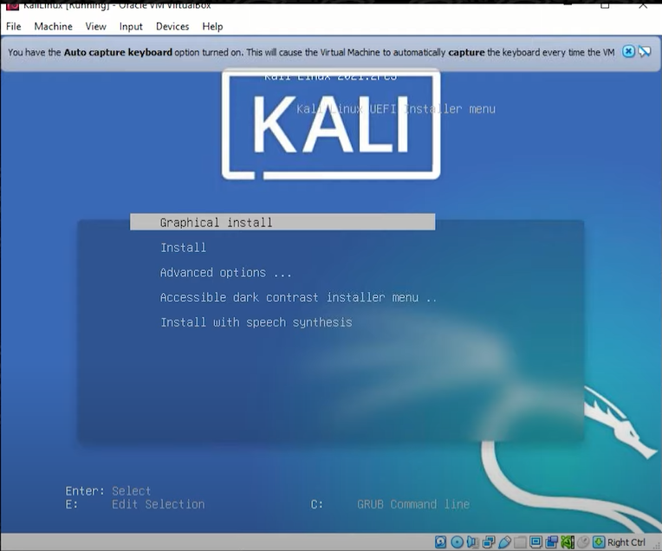

Now the setting up the languages and country zone.

After that setting up the disk partitioning

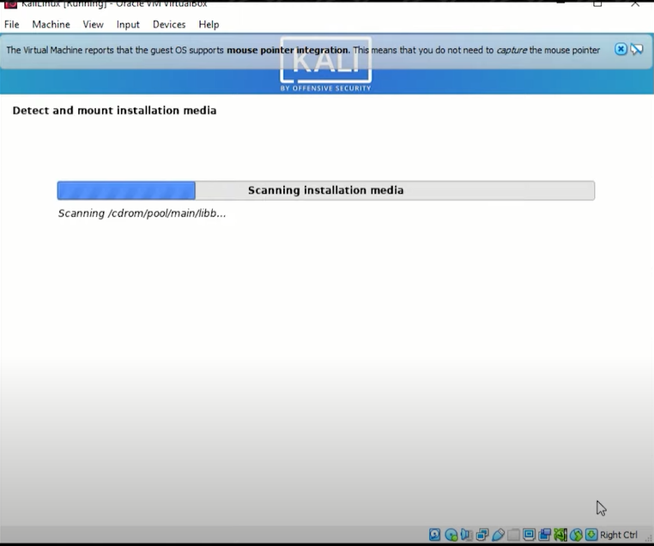

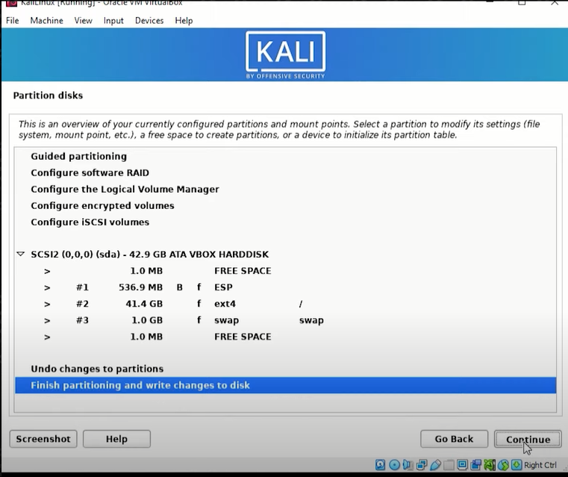

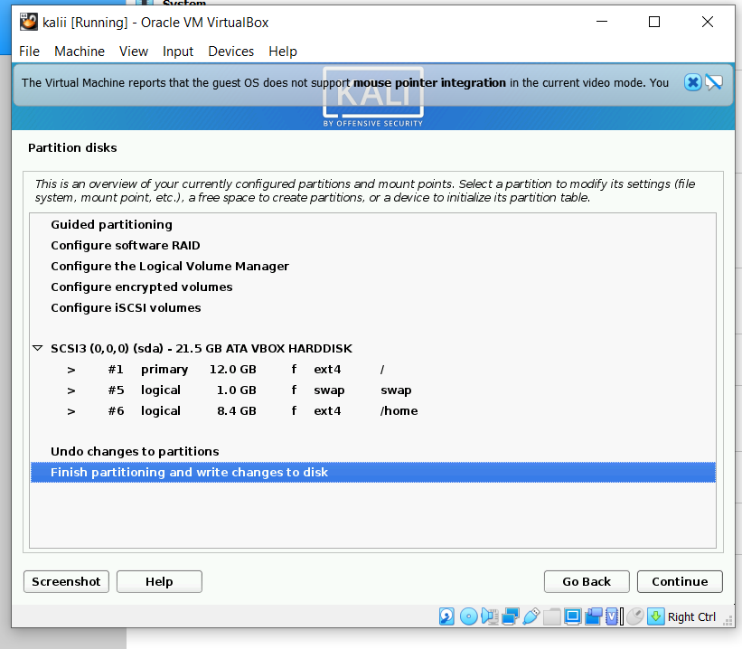

After setting up the username and password.

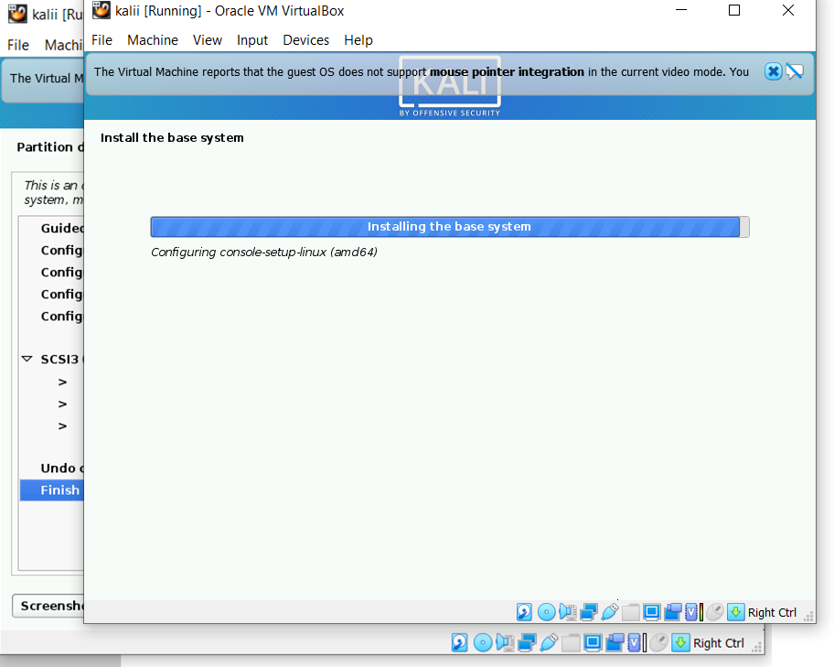

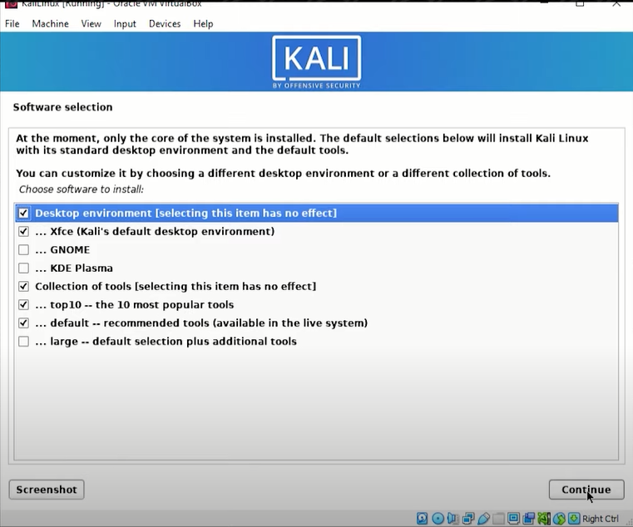

Installation Completed

## Now start the machine to use the environment.

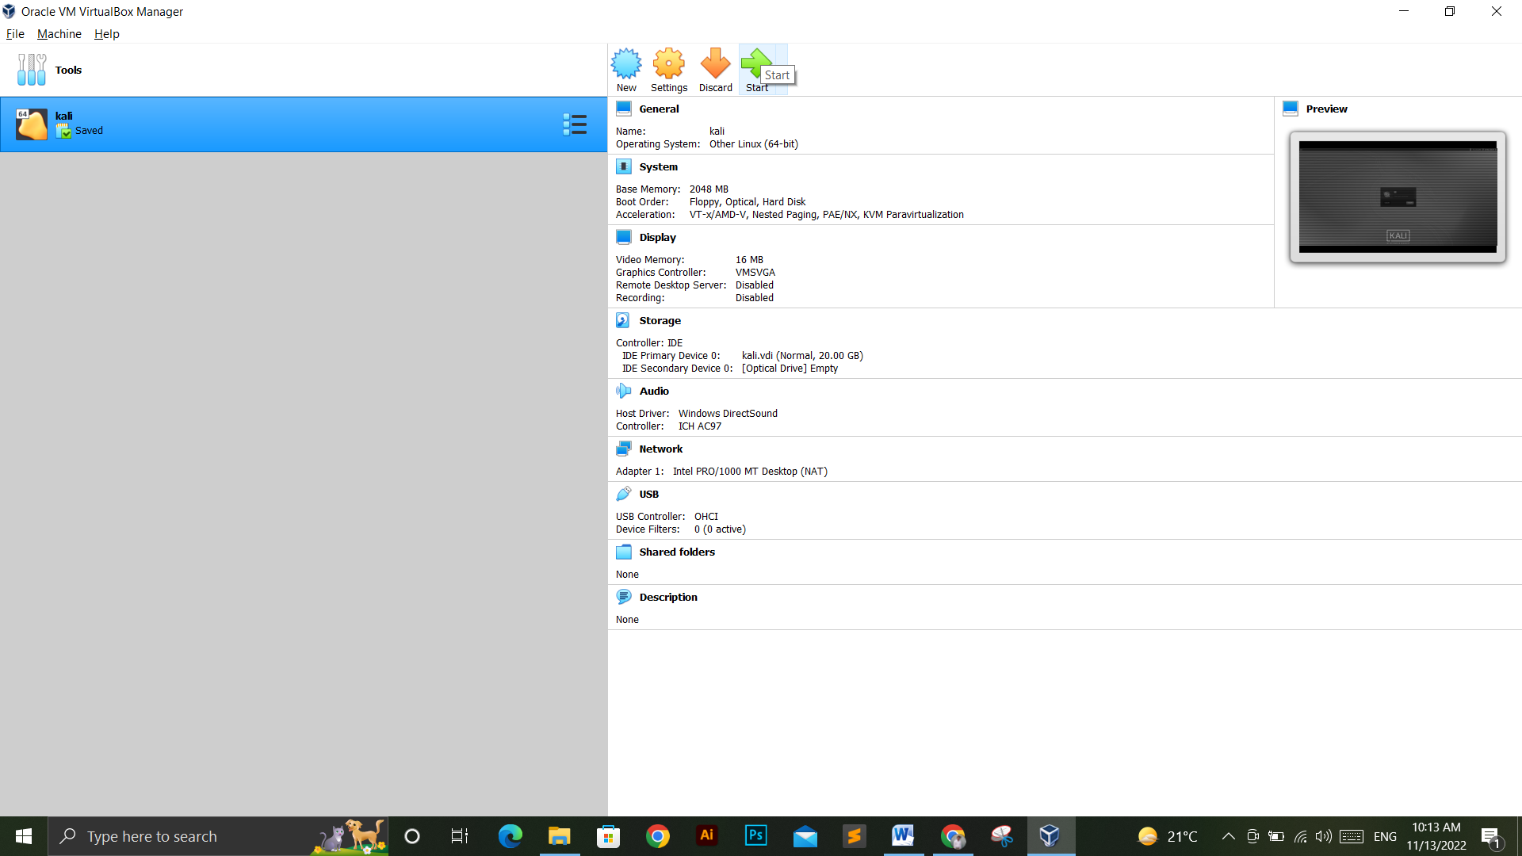

## Logging into the Kali Linux VM



Home Screen of Kali Linux Virtual Machine

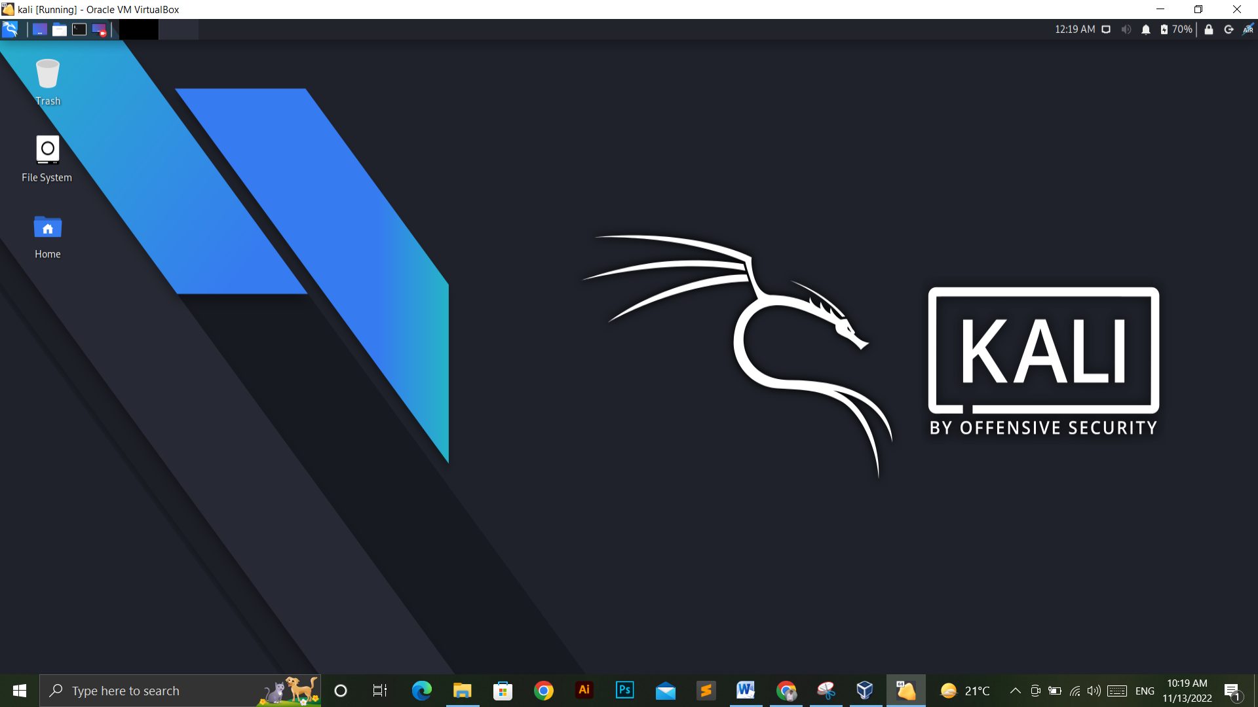

Pre Installed Tools in Kali.

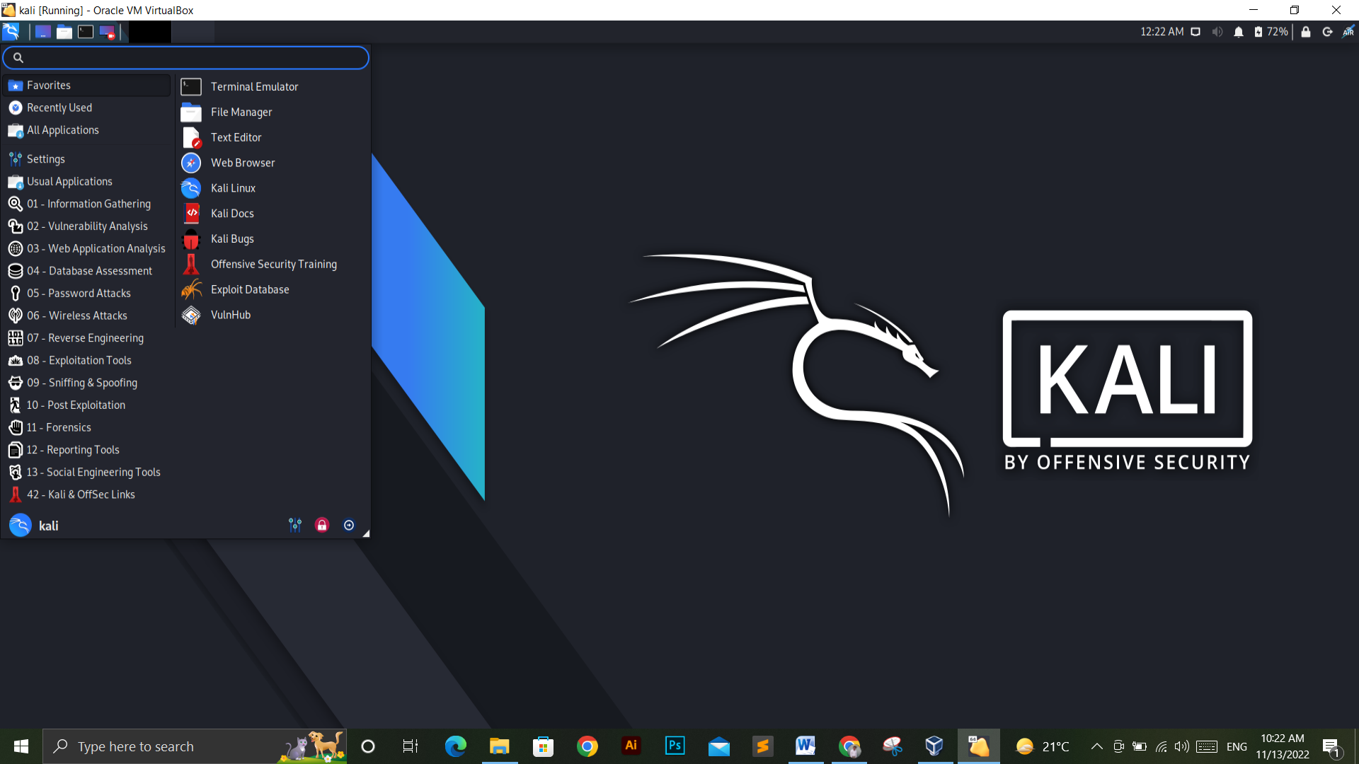

Shutting Down the Machine

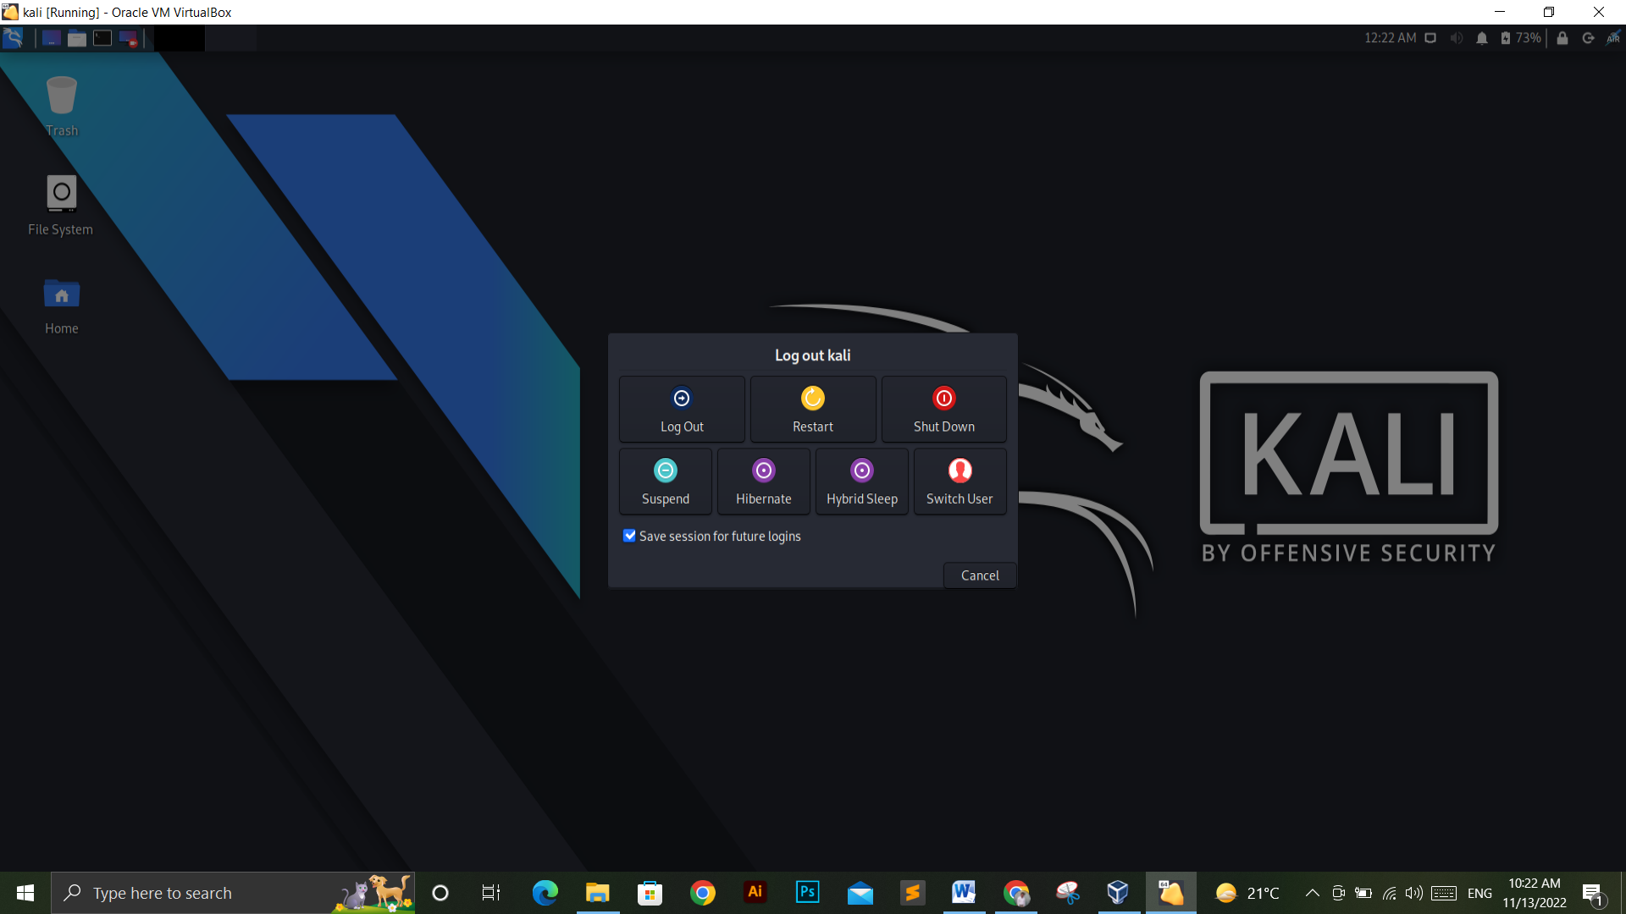

# Task 2:

Setting up Metasploit framework

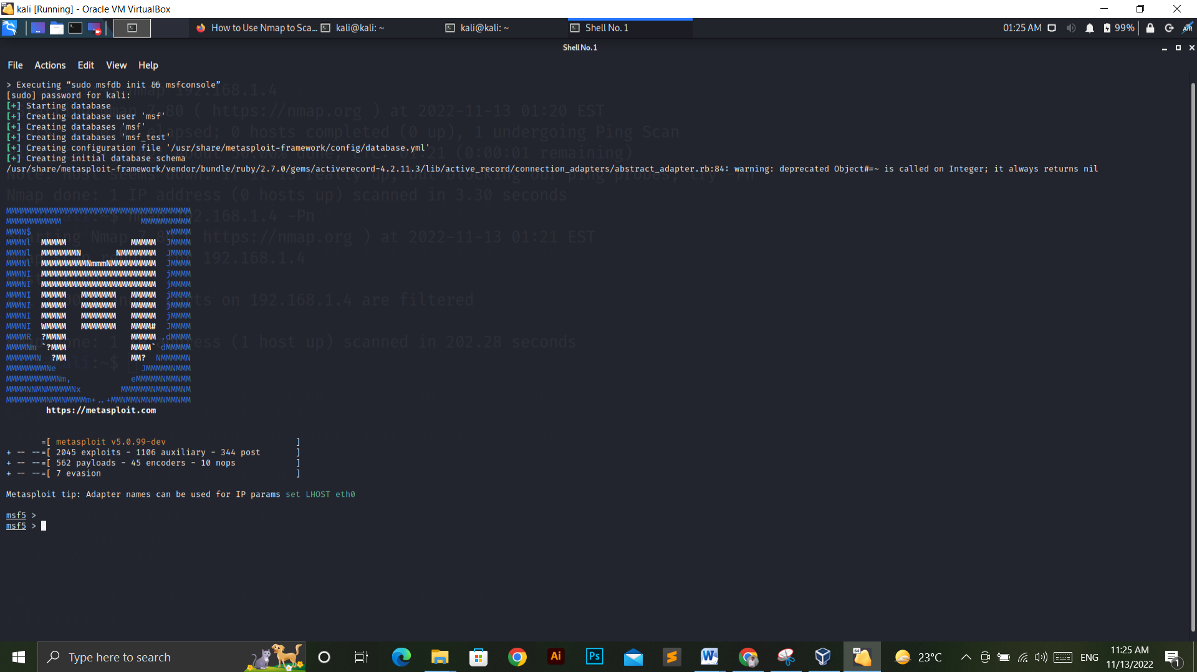

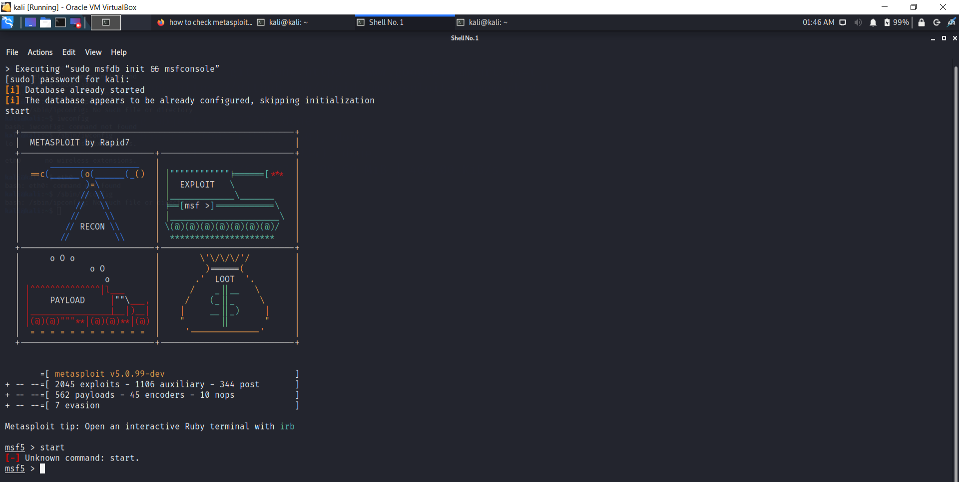

## (A). Demonstrate the steps a hacker can perform for network scanning using any appropriate tools and analyse their results

NMAP is a network mapping and port scanning tool. It can be used to determine which devices are connected to a network, what services they are running, and what ports they are listening on.

This can be used to discover vulnerabilities in devices or services that may be exploitable by an attacker.

NMAP will usually not be able to penetrate a firewall due to the way it works but it can give you a good idea of what devices are connected and how they're configured so that you can start working on improving the security of your network.

## Installing NMAP

Open the terminal from kali linux and write the command

“sudo apt install nmap” to install NMAP (Network Mapper).

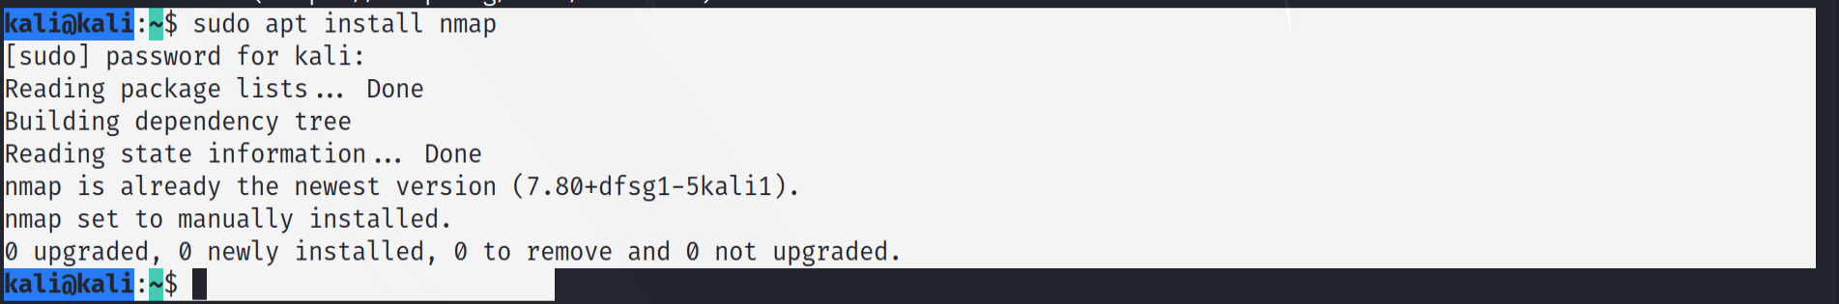

## Network Scanning

Firstly we have to know about the IP address of the network using command **ifconfig**. Sometimes this command doesn’t work directly from the terminal. So, it can be run from the directory “/sbin” e.g /sbin/ifconfig

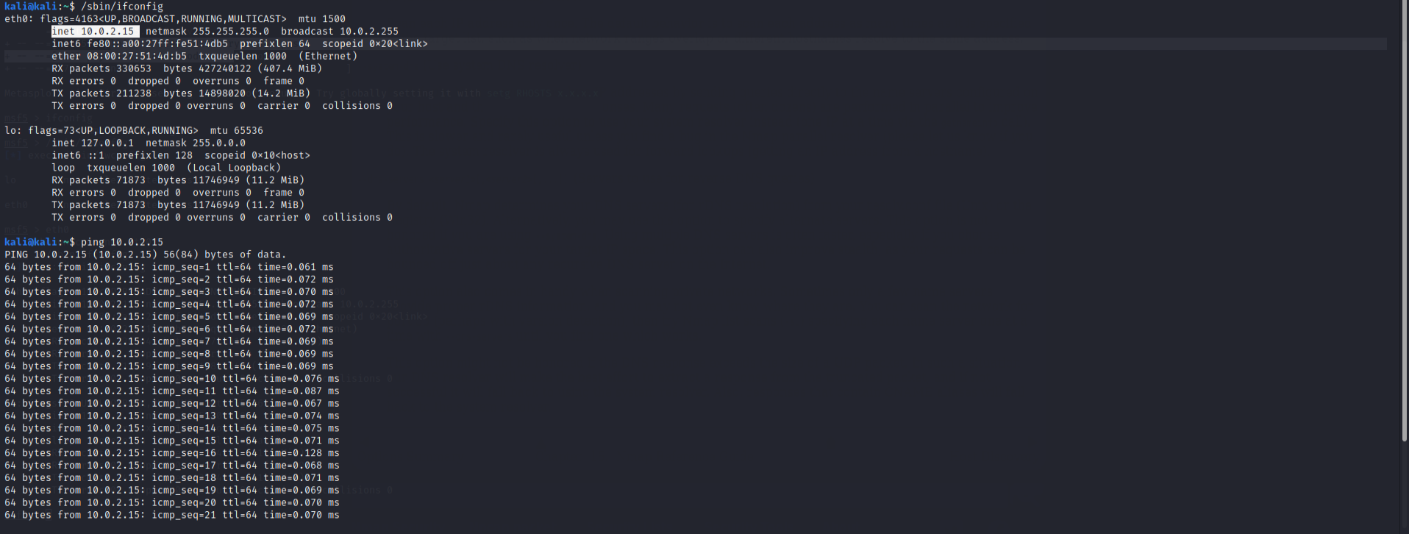

The IP address of our network is **10.0.2.15.** Once determining the IP address let check for the ping using **ping 10.0.2.15** command.

## Network Scanning using IP#.

NMAP 10.0.2.15



The target network has all closed ports. This can’t be exploiting, in this case.

Now trying to scan port 80 for all the network from 10.0.2.1 to 10.0.2.15.

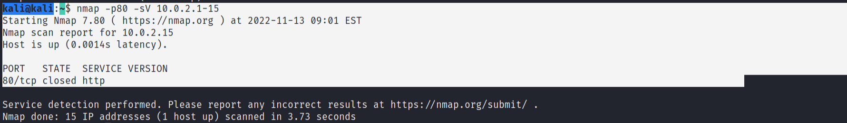

Starting the apache service using ‘service appache2 start’



Now we will get an open port finally.

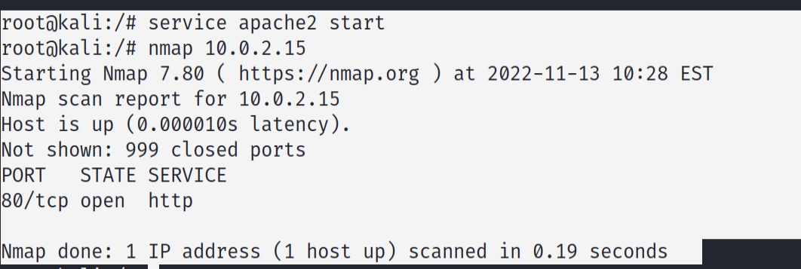

Now Checking the Open port on SearchSploit with http

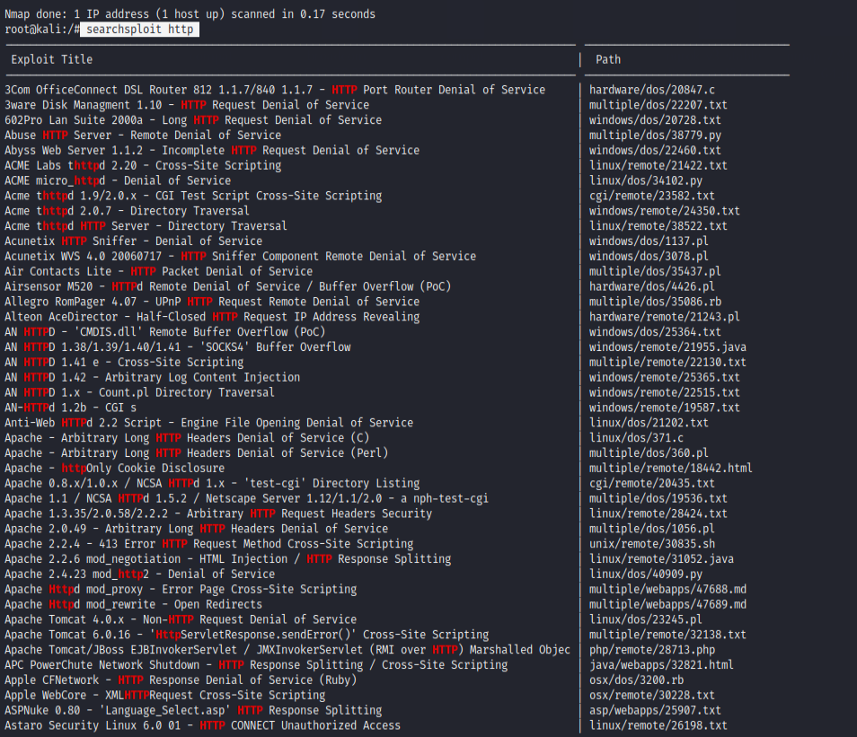

## Exploiting port using Metasploit “Metasploit-Framework”

Start metasploit using the command ‘msfconsole’.

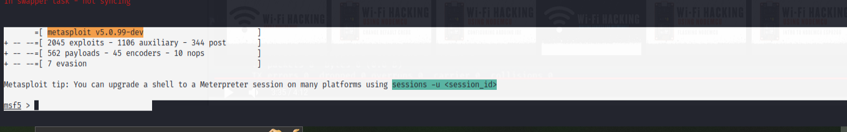

Searching for http on metasploit using command ‘search http’

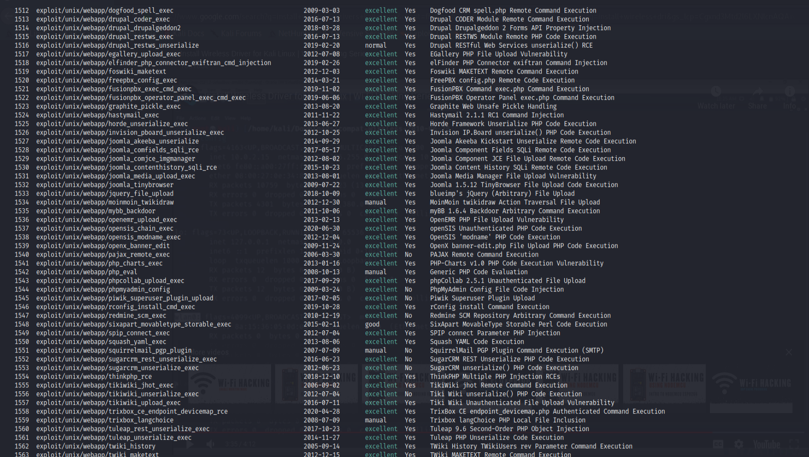

Now getting information from the current open port



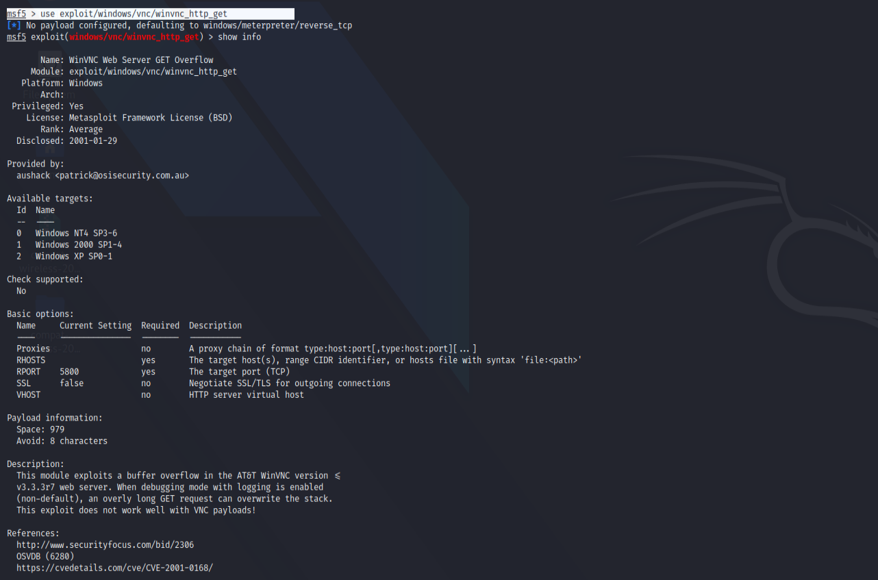

## Checking the information of Remote host and Remote Port

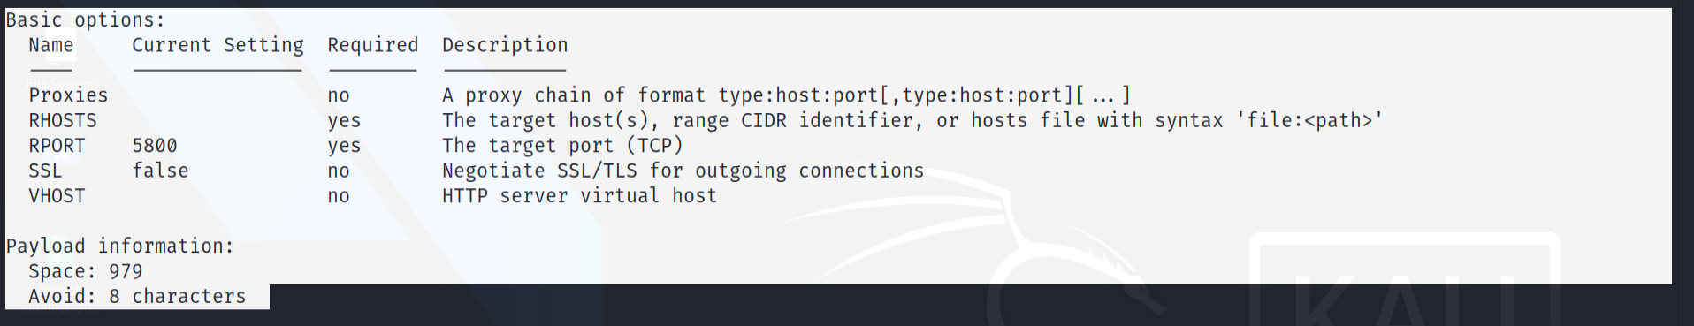

Now, we are going to set RHOST as our IP address which was 10.0.2.15 by using command

set RHOST 10.0.2.15



Now, Exploit it.



## Exploit Successful.

# (C) Man in Middle Attack

Performing Man in Middle Attack using

Tools used for MITM attack **ettercap, sysctl Command and ipv4 scaning.**

STEP 1: opening the terminal in root mode:

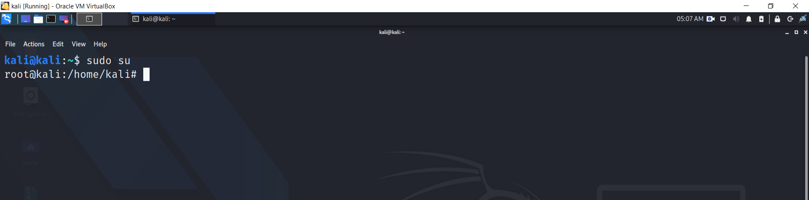

STEP 2: write the command in terminal=> sysctl –w net.ipv4.ip_Forward = 1

Which means we are going to allowing IPV4 forwarding.

STEP 3: Open Ettercap Application in Graphical Mode which is “Ettercap Graphical”.

STEP4: Select the Network connect which is eth0 in this case.

STEP 5: Now scan for the number of hosts in the network.

STEP 6:

tcpdump –i eth0 –n port 80 and host 10.0.2.15

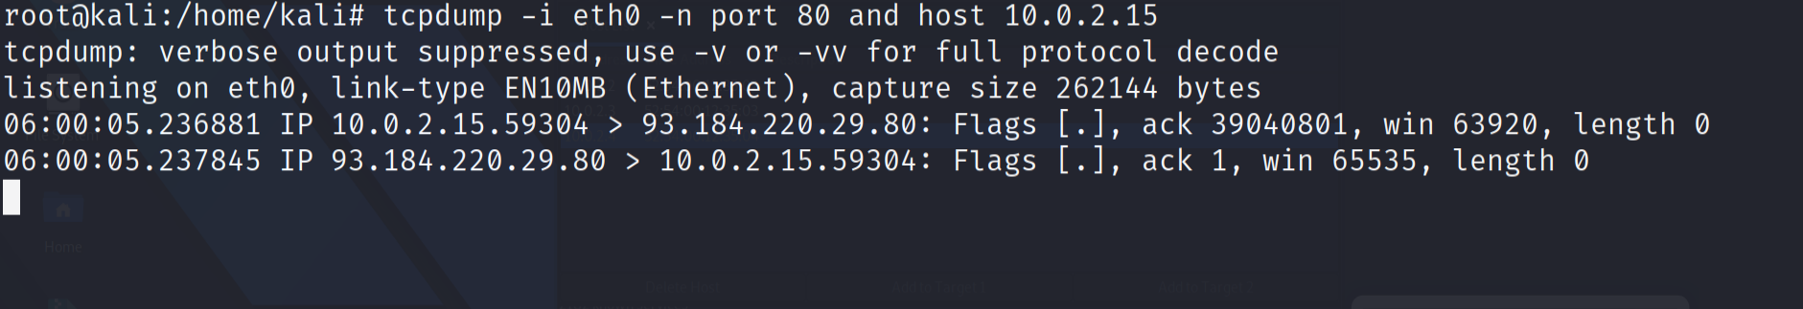

Tcpdump –I eth0 –n port 53 and host 10.0.2.15

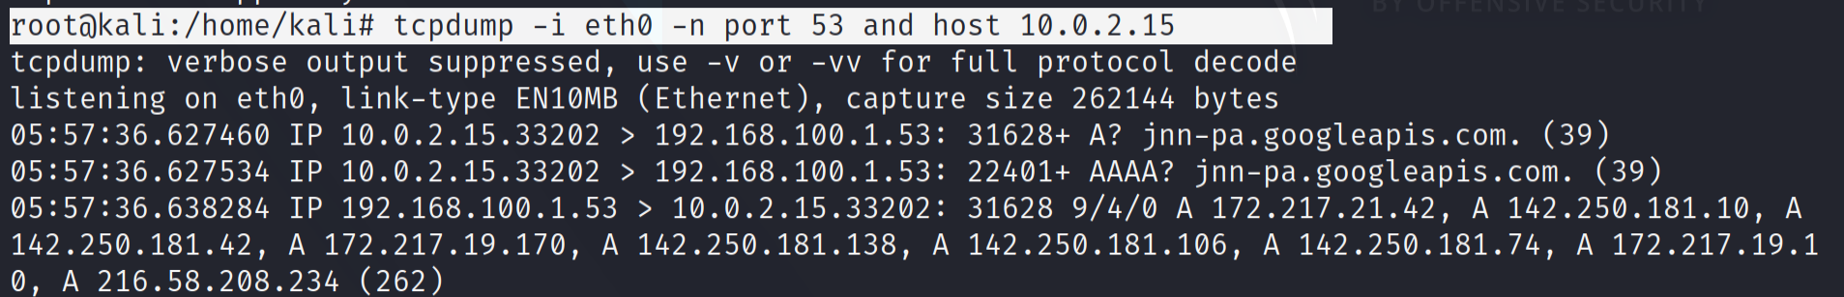

## (D) Penetrating and Hacking the Data from HTTPS

Site security is so critical and all site owners try to protect their site and information from being hacked by hackers for this reason. Everyone searches for updated, news related to site security to make their site, more secure day by day. What is HTTP? Hypertext transfer protocol is one of the most common protocols used to transfer information between web servers and web browsers that uses codes for this transfer, which all of them are visible.

HTTPs is a protocol that allows websites to communicate with each other. This is why it is considered the most secure method of communication, but it can be hacked. There are several ways to hack HTTPs. They include:

Malware: Malicious software on a website can also be used to intercept communications between visitors and servers, as well as make changes to how data is displayed or stored.

By hijacking the encryption process itself.

By tricking users into downloading malware that then steals their credentials

By impersonating websites so that victims think they're logging into their accounts while they're actually entering credentials for a different site.

## (E) Network Access hacking using WIFI.

WPA or WPA2 is a family of WiFi security standards used by most modern Wi-Fi networks. A key feature of WPA2 is the use of a password that is transmitted during setup. A relatively small number of tools are available which allow brute forcing WPA/WPA2 handshakes, which can lead to device exposure. The presence of these tools is a risk factor for organizations deploying access points and clients.

Wifi Hacking Tools:

1. Aircrack-ng

Aircrack-ng is a command line tool that uses the wireless card in your computer to crack WiFi passwords. This can be used by penetration testers, remote network monitoring and security professionals, but it is also suited for developers and hackers. With aircrack-ng, you can easily find out who has access to your network and understand their activities.

1. Wireshark

Wireshark is a free and open source packet analyzer that allows you to view and analyze network packets. Wireshark is useful for troubleshooting and debugging issues with communication protocols, detecting corruption, inspecting traffic between hosts at sites or organizations.

1. Kali Linux NetHunter

Kali Linux netHunter is a penetration tool and network forensics. It is used for internet service monitoring and security assessments, so it can be used in a variety of applications. It provides a context-dependent monitoring interface that runs on top of multiple operating systems, including the Linux base distribution of Kali Linux. It gives the user a graphical front end to netHunter, which provides automatic and manual network connection discovery and closing.

Step by Step procedure to hack wifi password:

Step 1: Installing aircrack-ng tool for wifi penetration, using install command.

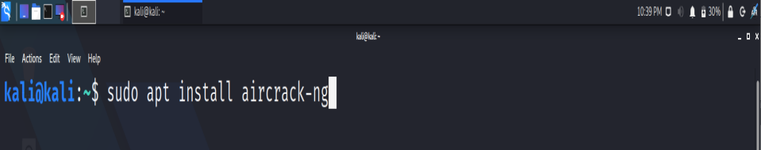

Step 2: Type ‘y’ and press Enter.

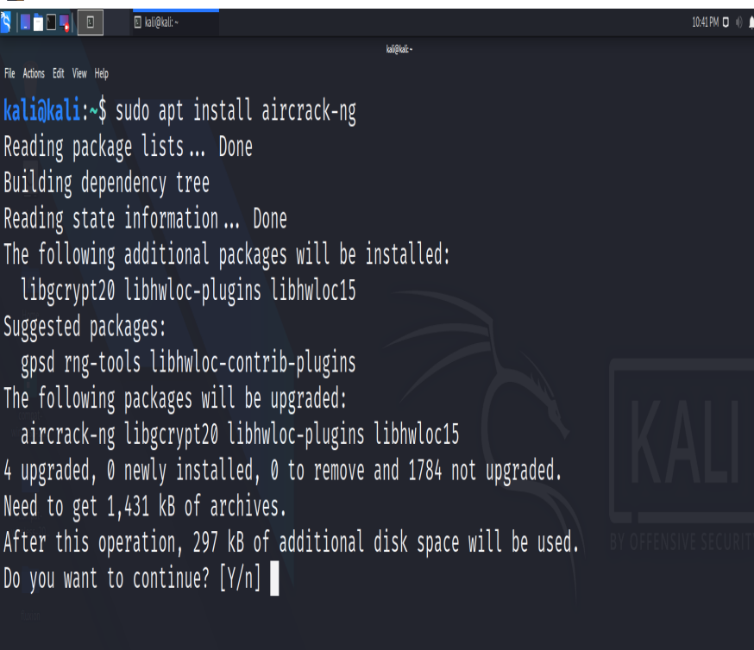

Step 3:

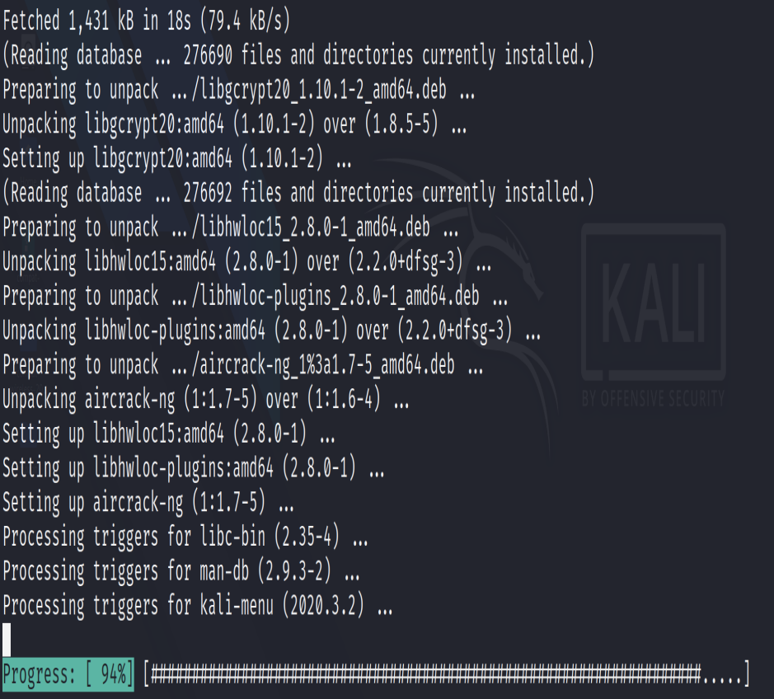

Successfully Installed: Now Run the Aircrack-ng from the menu.

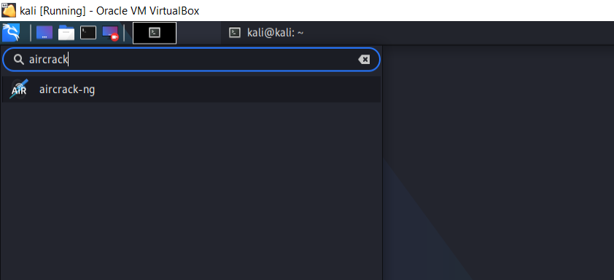

Check Network connection using iwconfig command

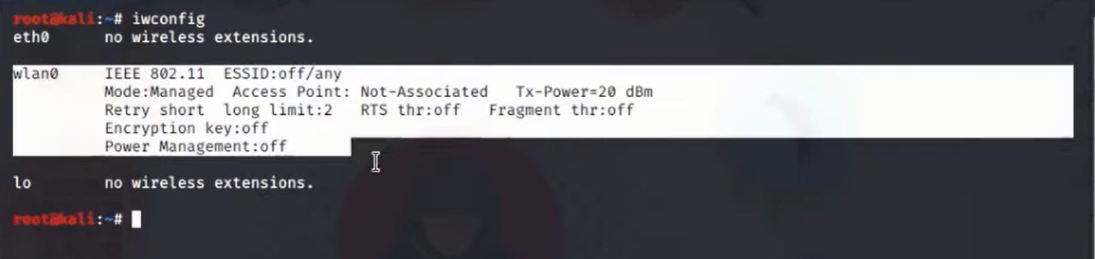

Activating monitor mode for connection using airmon-ng command.

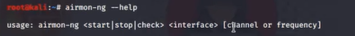

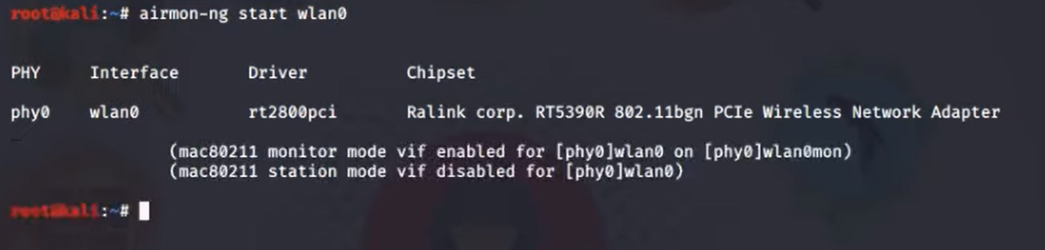

Now the monitor mode is activated

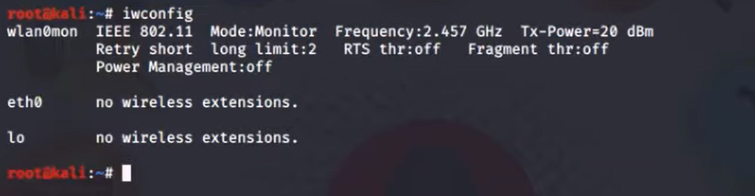

Now checking the mode and capturing the access points

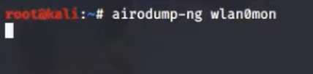

Here we have captured the target point.

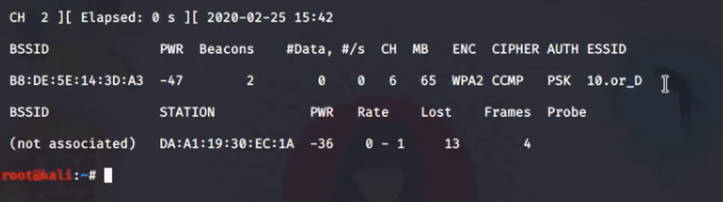

Getting access to the wlan0mon with its channel number and MAC id.

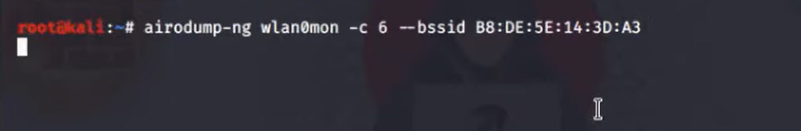

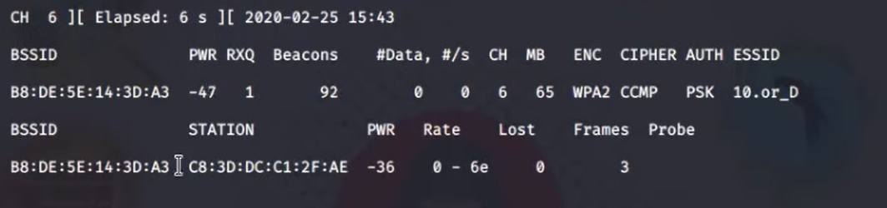

Let perform wifi deauthentication attack.

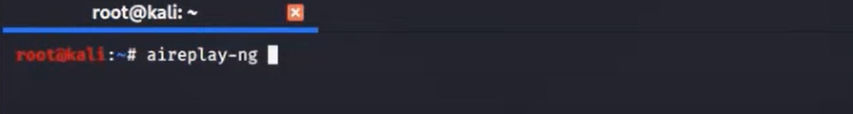

Activating –deauth command and deactivating the authentication.

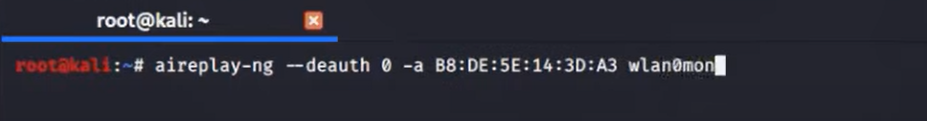

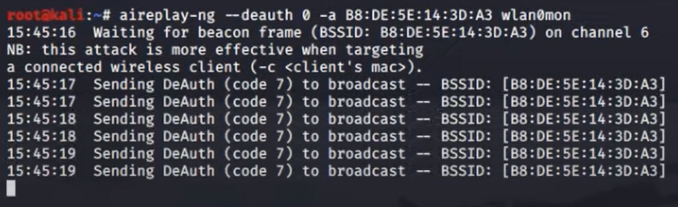

The handshake process is the first step in a WPA2-Enterprise handshaking protocol, in which a WiFi device sends certain packet types in order to obtain a shared key for further communication. The captured file is the one that you could use to get access to any network.

Handshake process is captured.

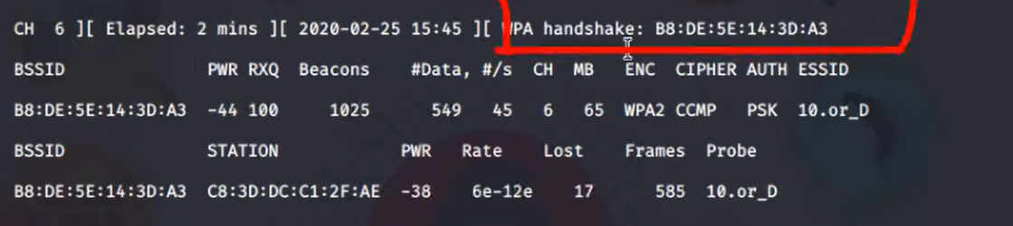

Now try to decrypt the handshake. Sending wordlist and capture file to crack wifi.

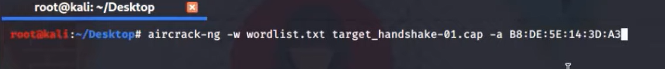

Handshaking is started.

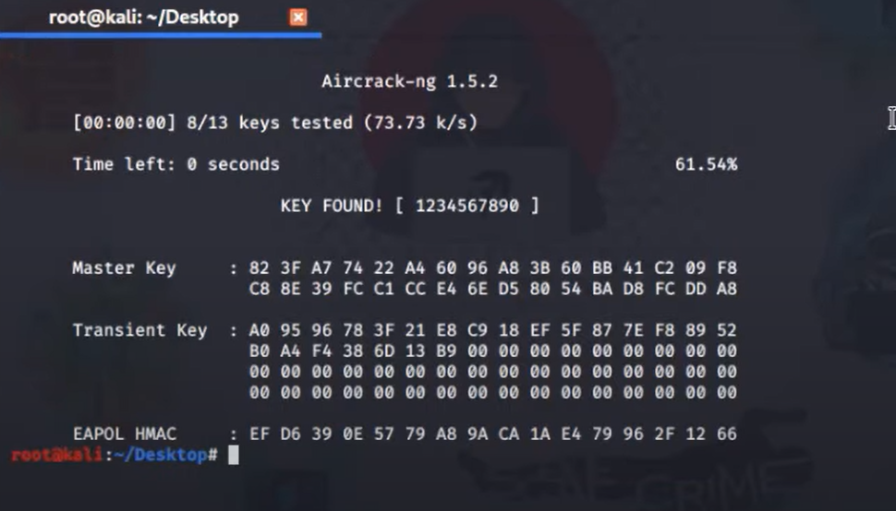

Once the key is found, try to enter the key and connect the wifi.

disable the monitor mode.



Now starting network manager using

Root@kali: services network-mamager.

## (F) Social Engineering Attack

A social engineering attack is an attempt to gain access or information through someone or something that would normally be trusted. For example, a company might provide security certificates to prove it's who it says it is. If a hacker receives those certificates from a fake website, they can use them to impersonate the real website.

## Types of phishing attack:

Email attack

Fake discount offers and Lucky Draw offers

Baiting and “quid pro quo” attacks

SMS and Voice etc.

## Tools use for Social engineering Attack

Using Zphisher tool for this attack.

ZPhisher is a hacking tool and another addition to the phishing toolkit that hackers are using. It helps them in creating the fake websites like banks, government sites etc in less time.

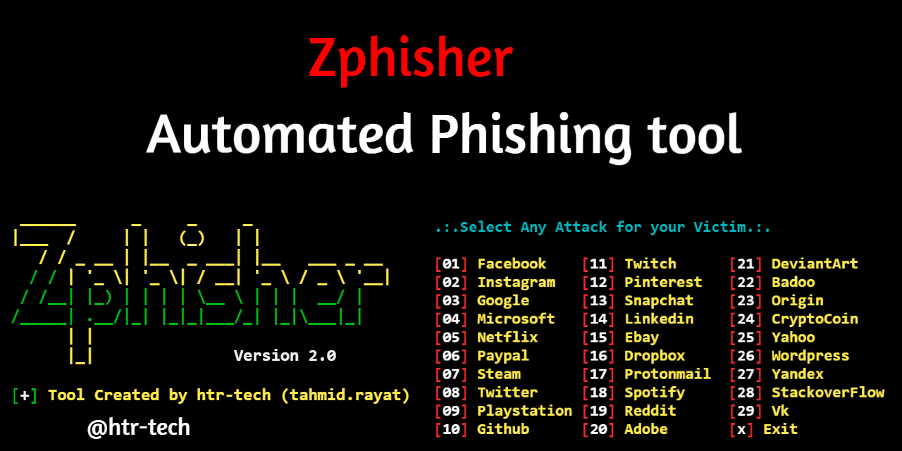

Cloning this tool from github by using the ‘clone git’ command.

clone git <https://github.com/topics/zphisher.git>

Now open the directory of zphisher and check list of all items in the directory.

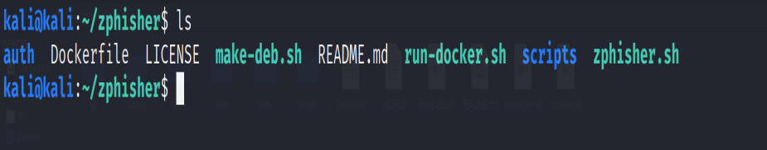

Now Run the bash file using bash command. [bash zphisher.sh]

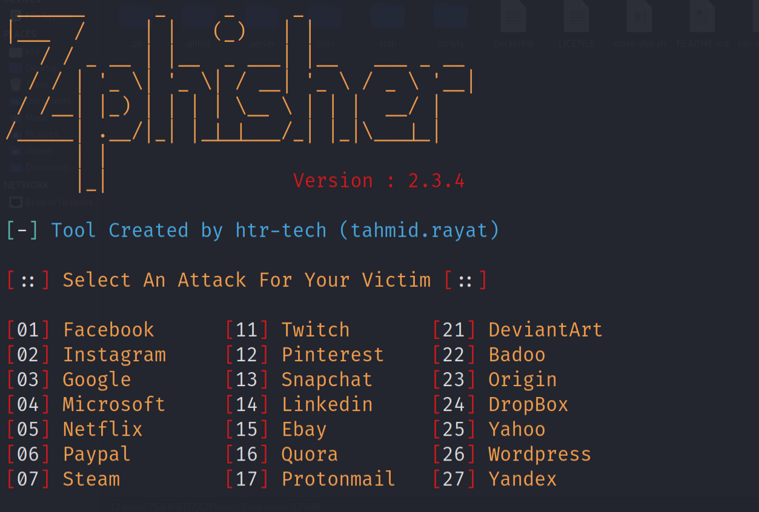

Now, from the list we can select any of above option to attck.

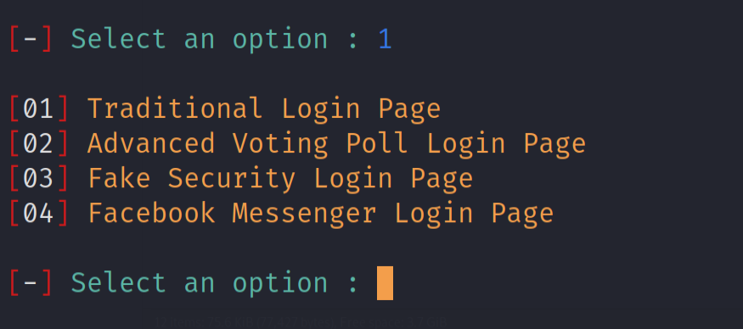

In this case facebook is selected, now select the page option. Selected the traditional login page

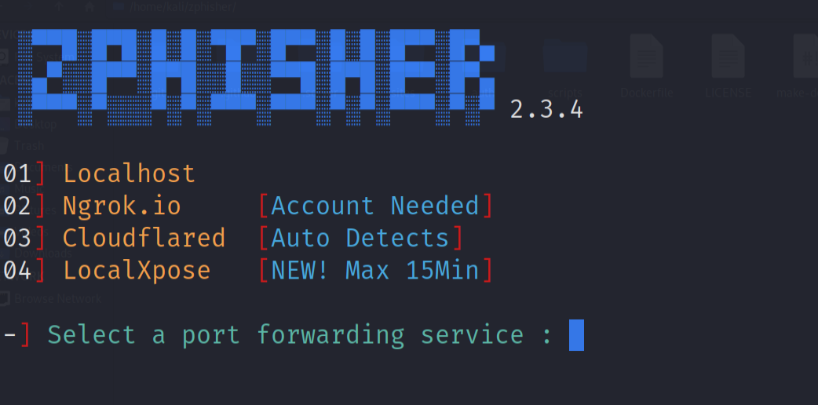

Now select the server type. Here we are going to select cloudflared. Ngrok.io could be selected but it required to signup.

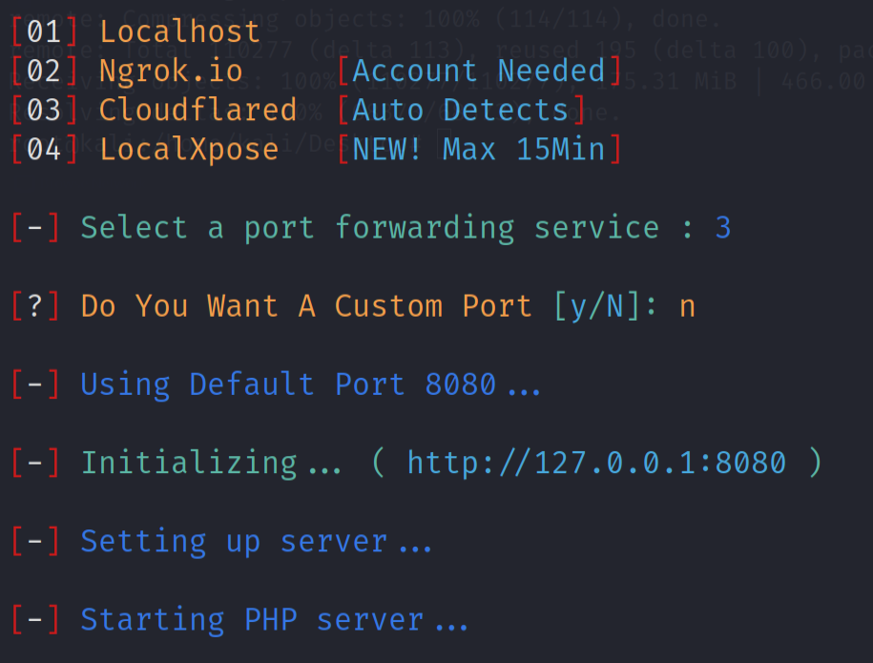

Now the Zphisher will generate a URL that can be shared to targeted person, when he/she visit the url, Zphisher will capture its IP number and once the user enter the user credentials in the login form ZPhisher will capture that data.

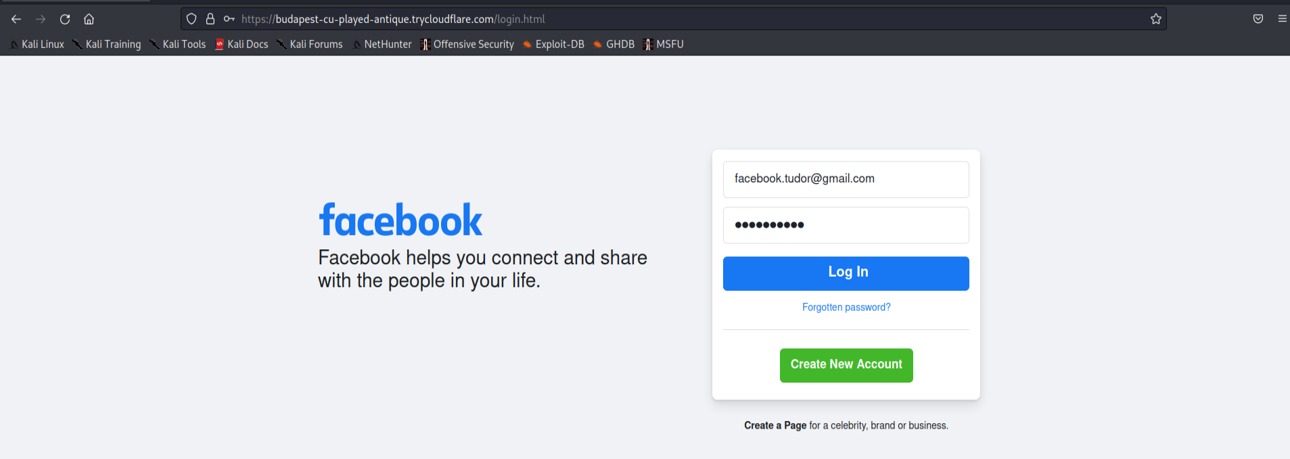

Here Zphisher found the IP#.

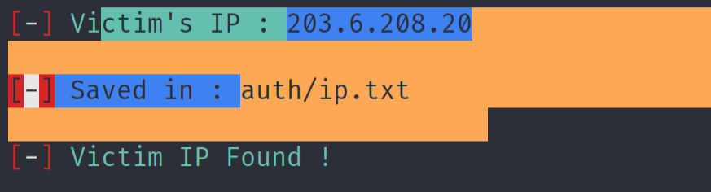

Now after filling and submitting the form it will display the user credentials.

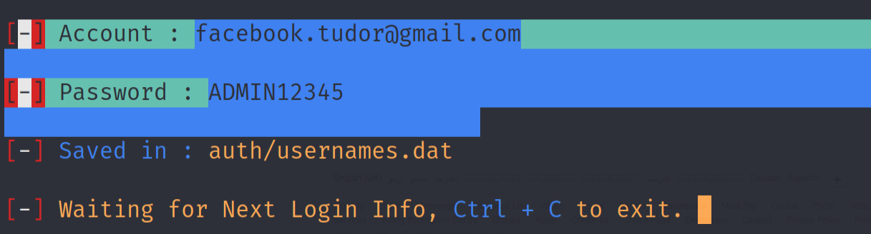

That how a hacker can gain user data and can hack user social media and other accounts.

# Task 3

## Protection from social engineering attack

Social engineering is an attack that relies on the attacker pretending to be a trusted person or company in order to gain access to a system. In most cases, this includes exploiting the trust of people in the organization, such as IT administrators and system administrators.

Social engineering attacks are often executed by leveraging relationships between users and systems. For example, an attacker might use their existing relationship with a user in order to impersonate them and trick them into providing sensitive information. Social engineering can also be used to access sensitive data or systems by posing as someone who has permission to do so. A security policy should address how an organization will detect and respond to social engineering attacks in their environment. This policy should define what actions will be taken when a breach is detected, as well as any other actions that may need to be taken in response. An effective security policy will also include procedures for reporting suspicious behavior or events occurring within the environment so that they can be investigated thoroughly by security personnel.

Social engineering is the manipulation of people into performing actions that they would not normally perform, for example by a person pretending to be from the IT department asking for passwords. The first line of defence against social engineering attacks is education of staff members, who need to understand how common these types of attacks are, how they occur and how they can be prevented from happening in their organization.

# Task 4

## Conclusion

Network security is a top priority for companies today. Most businesses are aware of the importance of network security, but few are willing to invest in it. They see it as an expense that will not pay off until after the damage has already been done. However, there are some steps you can take now that will help your business avoid potentially costly problems later on.

Network security requires a long-term investment from both IT and the business side of the house. It's not something that can be ignored just because no one is sure where it fits into their budgeting process. Companies need to start thinking about network security as an important part of their overall strategy, rather than just something they do once they have been breached or targeted by hacker.

Physical security refers to protecting systems against physical intrusion by unauthorized individuals or devices. It includes guards, fences, alarms and other measures to protect facilities against theft and sabotage. Physical security also includes access controls that prevent unauthorized people from accessing computers and servers through vandalism, theft or other means.

Procedural security refers to the ways in which computers are used within an organization and how they are protected against unauthorized use. For example, only authorized users should be allowed to log into computers; firewalls can be installed between remote sites so that no traffic from one site can enter another without proper authorization; passwords should be changed regularly; etc..

Technical security refers to restricting the functions that can be performed on computers and networks based on user authentication or network access rights (e.g., IP addresses).

# Reference(s):

1. Anoruo, C. (2019). Employing COBIT 2019 for Enterprise Governance Strategy. Available at: <https://www.isaca.org/resources/news-and-trends/newsletters/cobitfocus/2019/employing-cobit-2019-for-enterprise-governance-strategy>.
2. CGI (2016). IT Security Governance. A Holistic Approach. Available at: https://www.cgi.com/sites/default/files/white-papers/it-security-governance.pdf
3. Cisco (2020). What is Cybersecurity? Available at: <https://www.cisco.com/c/en/us/products/security/what-is-cybersecurity.html>
4. Diligent (2016). Five Best Practices for Information Security Governance. Available at: <http://diligent.com/wp-content/uploads/2016/10/WP0018_UK_Five-Best-Practicesfor-Information-Security-Governance.pdf>
5. Erickson, J. (2007). Hacking: The Art of Exploitation. (2nd Edition) San Francisco: No Starch Press.
6. IT Governance (2020). What is Cyber Security? Everything You Need to Know about Protecting Your Organization from Cyber Attacks. Available at: <https://www.itgovernance.co.uk/what-is-cybersecurity>.

1. Solms, R., Thomson, K. & Maninjwa, M (2011). Information Security Governance Control Through Comprehensive Policy Architectures. Available at: <https://ieeexplore.ieee.org/abstract/document/6027522>

1. Udemy (2019). The Complete Ethical Hacking Course: Beginner to Advanced. Available at: <https://www.udemy.com/course/penetration-testing>
2. Udemy (2019). Learn Ethical Hacking From Scratch. Available at: <https://www.udemy.com/course/learn-ethical-hacking-from-scratch>
3. Wilkinson, D. (2014). Information Security and Governance Policy. Available at: [https://www.cqc.org.uk/sites/default/files/documents/20121115_information_security_ _governance_policy.pdf](https://www.cqc.org.uk/sites/default/files/documents/20121115_information_security_%20_governance_policy.pdf)